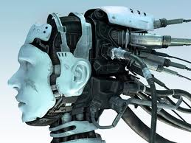
Digital Knowledge
A Lecture by Professor Peter de Bolla
University of Cambridge
This lecture asks if the move into the digital changs anything with respect to knowledge. Are the affordances of computational environments for scholarship merely enhancements to what we do in the old analogue ways? Faster, for sure, more efficient and on a larger scale. But is that all? Many scholars working in the humanities would take such a view. This lecture asks us to consider a rather different scenario in which both what we call ‘the humanities’ and ‘knowledge’ come under pressure. It argues that we have yet to figure out what that pressure might do with respect to what and how we know but one possibility is that the migration of analogue materials into digital has the capacity to create an alternative epistemology: digital knowledge.
Wednesday, September 17th
6.00pm English Department
Event Space, 244 Greene Street

