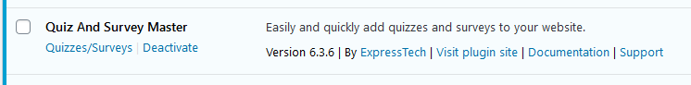

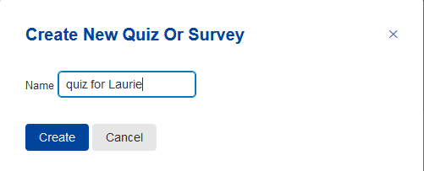
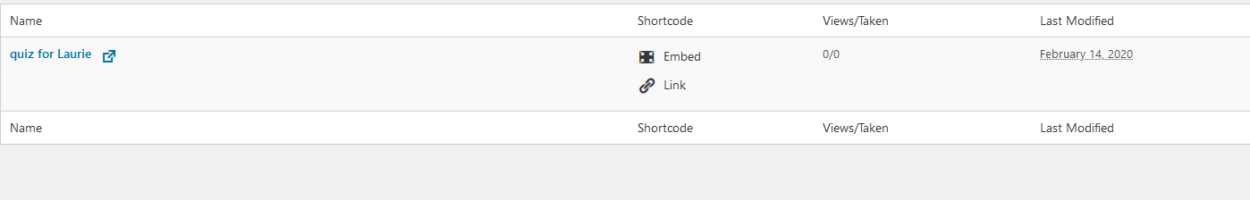
Hover over name to see Edit, click there
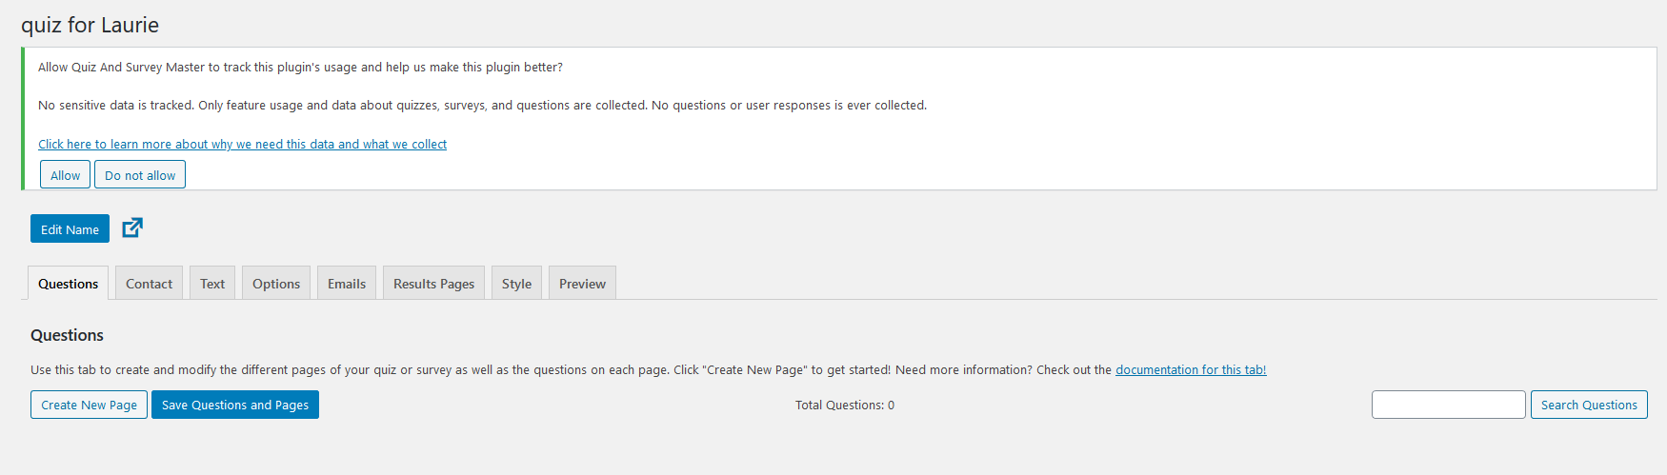

When I click on the “Check out the documentation for this tab!” link, I get a blocked url:

