Installation Guide

Step One
As our Download page describes, you can either install CBOX directly from the WordPress repository or download the CBOX software from the repository page and save it on your computer.

Step Two
Go to your WordPress dashboard and navigate to Plugins>>Add New. If you have downloaded the file, click on Upload Plugin and click on Browse to find the CBOX zip file you saved in Step One. If installing directly from its repository page, navigate there. Then, in either case, click Install Now. This will install the CBOX plugin onto your site.
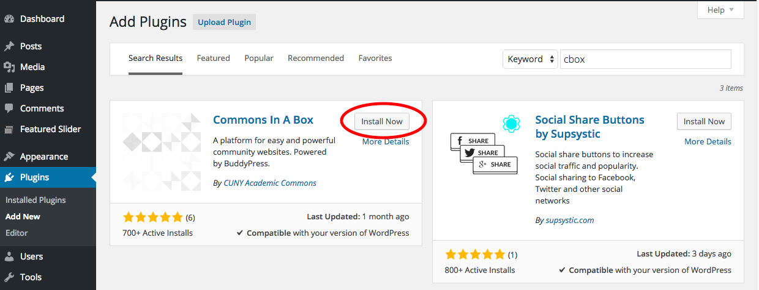
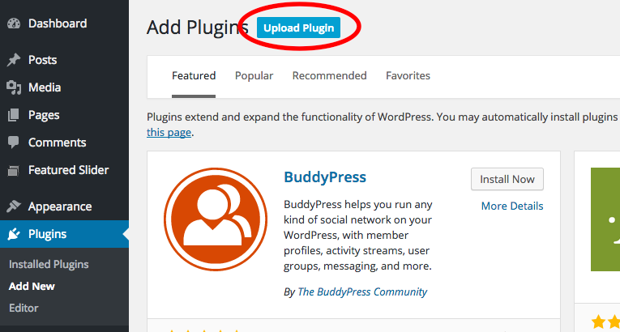

Step Three
Next, you need to activate the CBOX plugin. Following install, you should see the following:
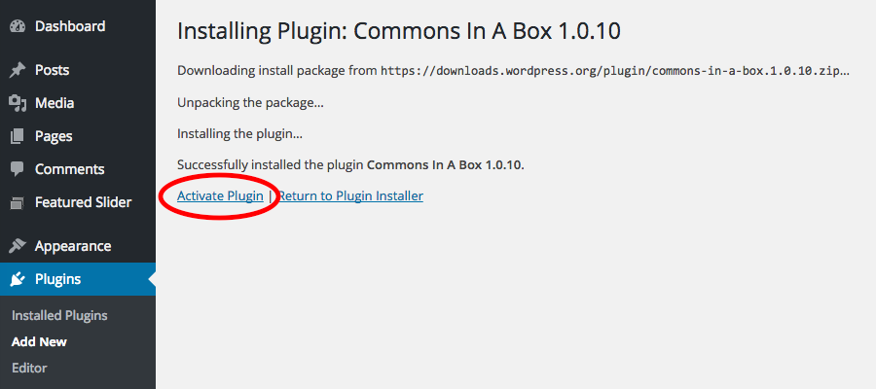
Click on Activate Plugin. You now have CBOX on your site, but you still need to configure its settings. You will be taken back to your Plugins page, but need to go through a few more steps for CBOX to be fully up and running.

Click on Commons in a Box in the left-hand menu:
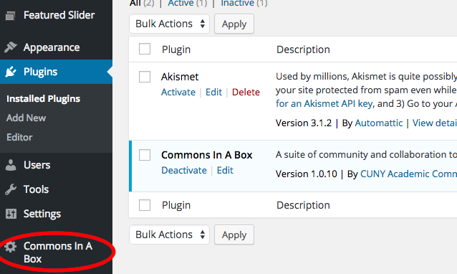

Click on Continue to install BuddyPress and other CBOX plugins.
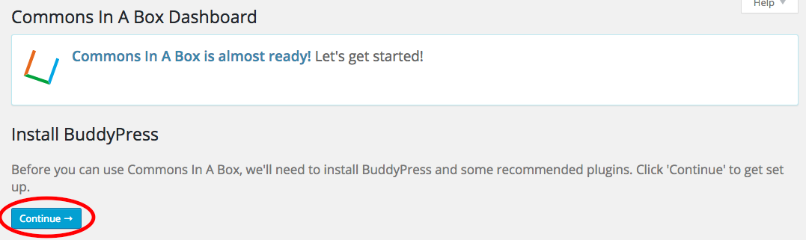

You should see the following:
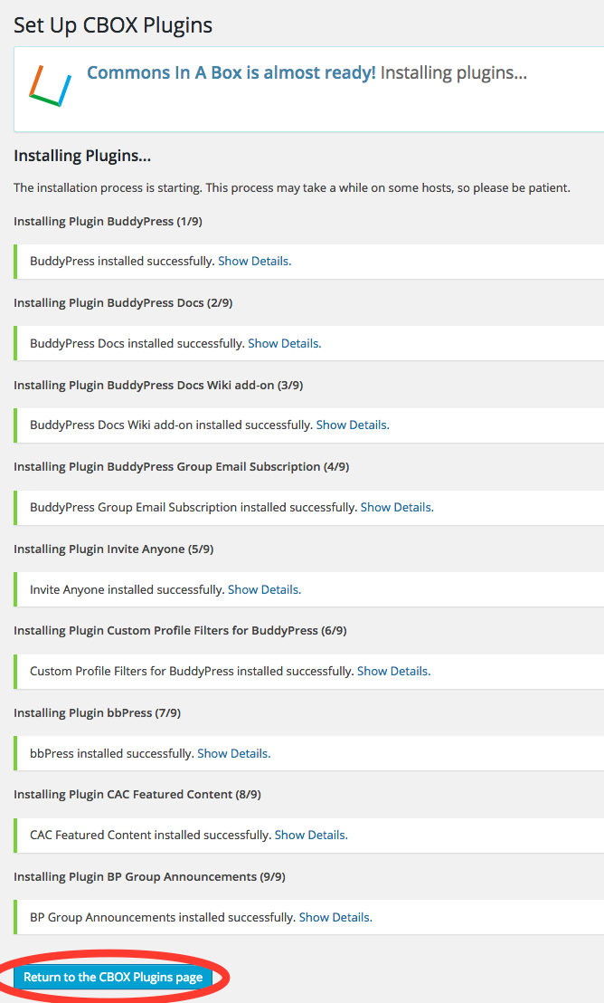
Click on Return to the CBOX Plugin Page.

Step Four
You’re taken to the Commons in a Box Plugins page where you can manage the plugins that were installed with CBOX. BuddyPress is a required plugin, but all of the other Plugins on this page can be deactivated if you choose.
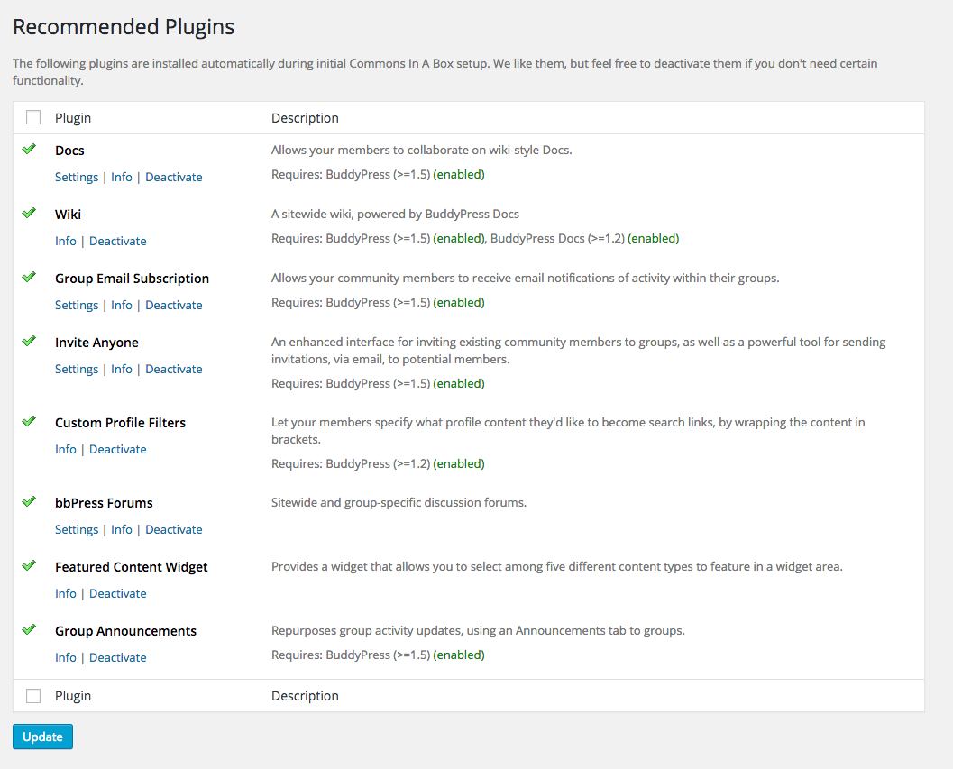

Buddypress provides a configuration panel for how it operates. To get to this, hover over Settings and then click on BuddyPress.
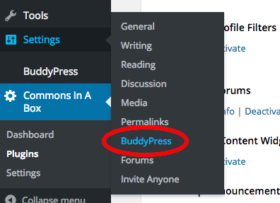

There are three tabs, and you’ll need to go through each to tailor BuddyPress functionality to your site’s needs. After finishing each tab, and before clicking the next tab, click Save Settings (These settings can always be changed from the CBOX Dashboard, after initial setup
Below is the first tab, Components:
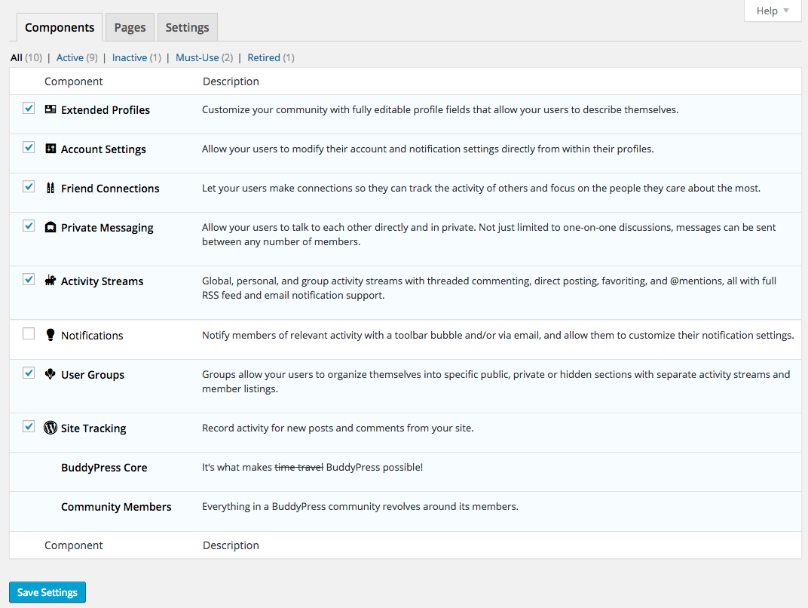

The second tab, Pages:
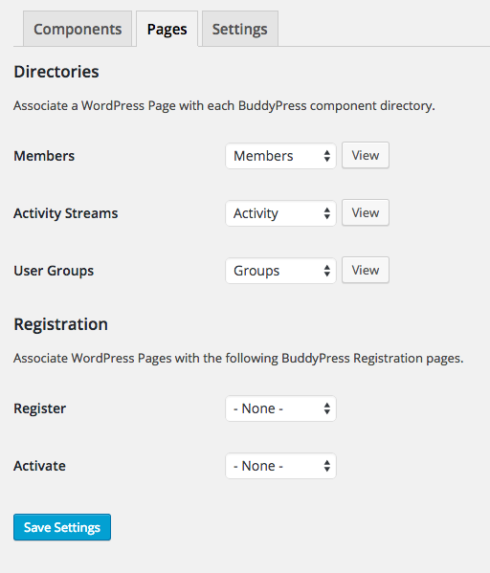

The third tab, Settings:
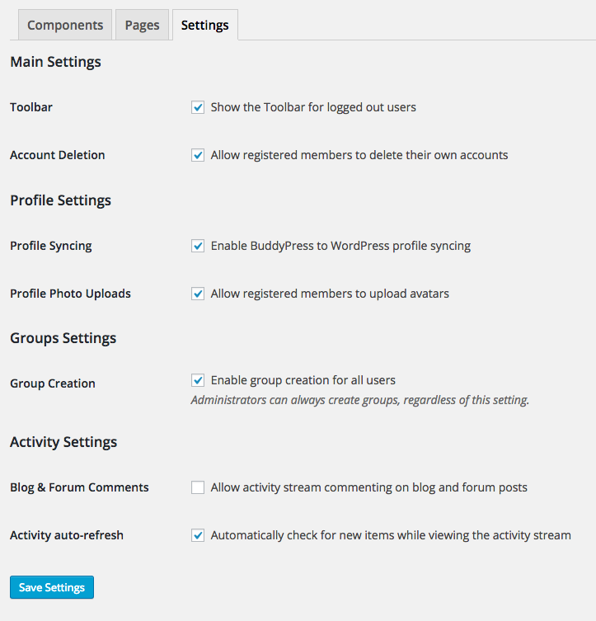
Once you have reviewed and saved each tab, your BuddyPress settings will be correctly configured for your site.

Step Five
If your existing theme is not a BuddyPress compatible theme, you will need to install one. CBOX provides a default theme – but you can choose any theme which is BuddyPress compatible. You will get the following warning if your theme does not work with CBOX:
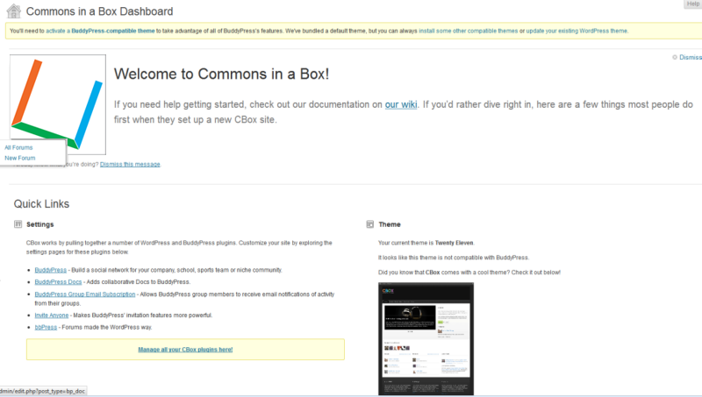

Congrats!
At this point CBOX is fully functional, and you can click on the CBOX tab in your dashboard to manage CBOX plugins and configure the CBOX theme. See CBOX Dashboard for more information

